Name: ________________________________________________________________________
Address: ______________________________________________________________________
City, State, Zip Code: ____________________________________________________________
Phone Number: ________________________________________________________________
Email: ________________________________________________________________________

RV Space – $40 per night (See next page for space reservations)
License Number & State | Total Length in Feet | Arrival Date | Departure Date
Type of Vehicle:
Class A | Class B/C | Fifth Wheel | Pop Up | Travel Trailer

Grooming Space – 5’x10’ spaces are $25 each; 10’x10’ spaces are $40 each.
Spaces include electricity.
Number of 5 x 10 Spaces
Number of 10 x 10 spaces

TOTAL: $__________________
Please make checks payable to GSCA

Space Assignment Requests (cannot be guaranteed): ___________________________________________________________________

Payment for reservations can be made via Paypal through our website www.gsca2018.com or by mailing this form and check to the address below.

Reservations due by September 17, 2018

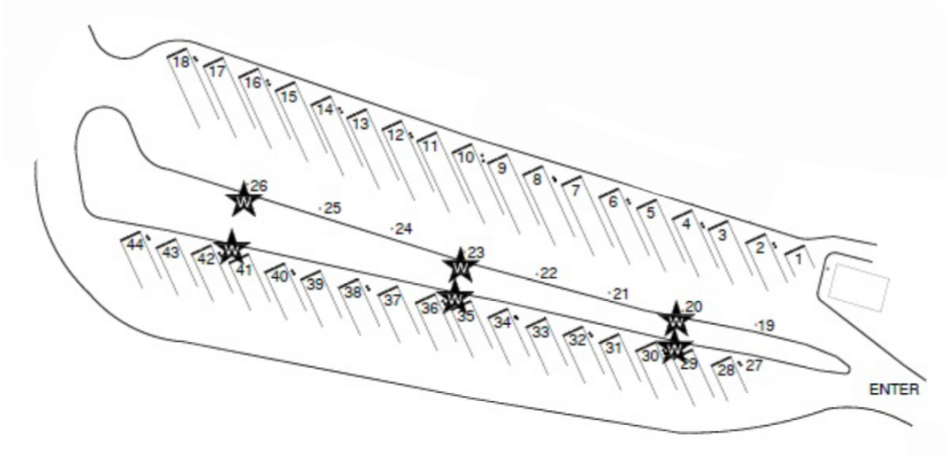

Space Reservation (Indicate space number):

1st Choice: ________
2nd Choice: ________
3rd Choice: ________

