2018 GSCA Western Regional Specialty
May 18, 2018
Vallejo, California

California Gold
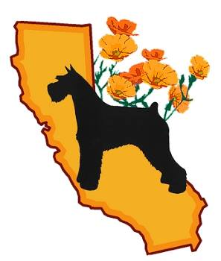

For Questions Contact:
Sandi Yanoff or Carie May

GSCA Western Regional Specialty and Supported Entry
Power Packed Weekend 4 show weekend May 18-20, 2018
May 18, 2018 GSCA Specialty
Sweepstake Judge: Ken O’Brien
Obedience/ Rally Judge: Cathy Dutra
Breed Judge: Mary Lou Just
Show Secretary : Judy Wilson:
http://jwshows.com
Northern California Working Dog- May 18, 2018
Supported Entry: Judge: Rick Gschwender
(SHOW SECRETARY)
Kathleen Davis
PO BOX 22107, C/O MBF
GREENSBORO NC 27420-2107
(336) 379-9352
http://pdf.infodog.com/prm/1163/prm1163.pdf

Coyote Hills Kennel Club
May 19 th- Supported Entry : Judge: Michel Chaloux
May 20 th - Supported Entry: Judge Frandel Brown

Superintendent: | MB-F Inc.  P O Box 22107  Greensboro NC 27420  PHONE: (336) 379-9352 FAX:(336) 272-0864  http://www.infodog.com  RV parking available  Airport accessible from SFO, Oakland and Sacramento

